LKM - accenture
Elastic beanstalk

AWS Elastic Beanstalk helps you to easily deploy and manage applications. Elastic Beanstalk supports applications developed in many languages like Go, Java, .NET, Node.js, Python, PHP as well as different platform configurations for each language. We don’t need to worry about the infrastructure the runs the applications. You simply upload your application, it handles capacity provisioning, load balancing, scaling and application health monitoring.

Update version

New version

Here are the following steps on how we can deploy the application in the elastic beanstalk environment. We simply upload our code and the rest will be handled by the elastic beanstalk to run our applications.

Create a new application.
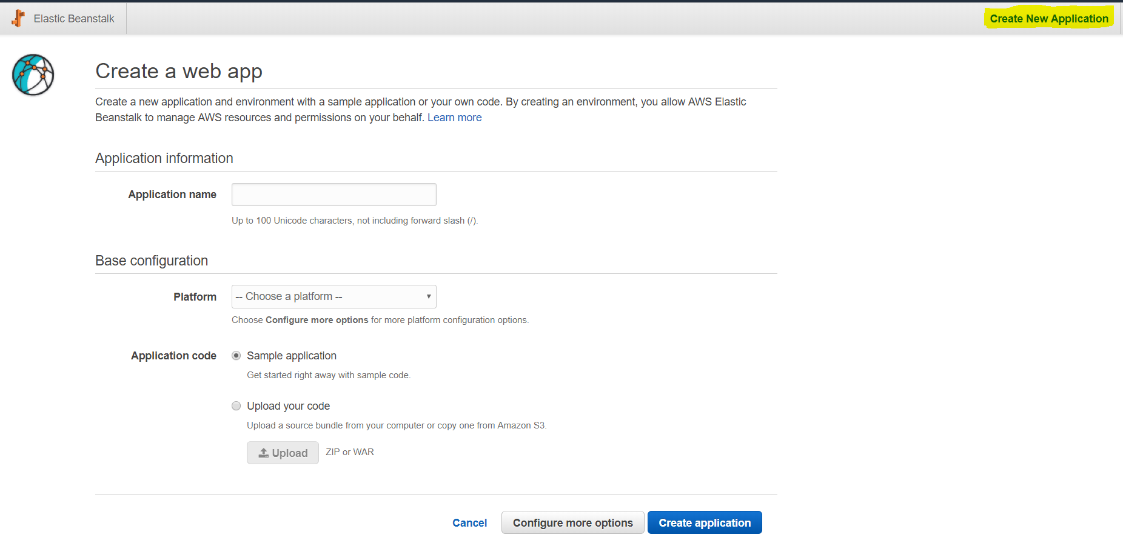
Create Application
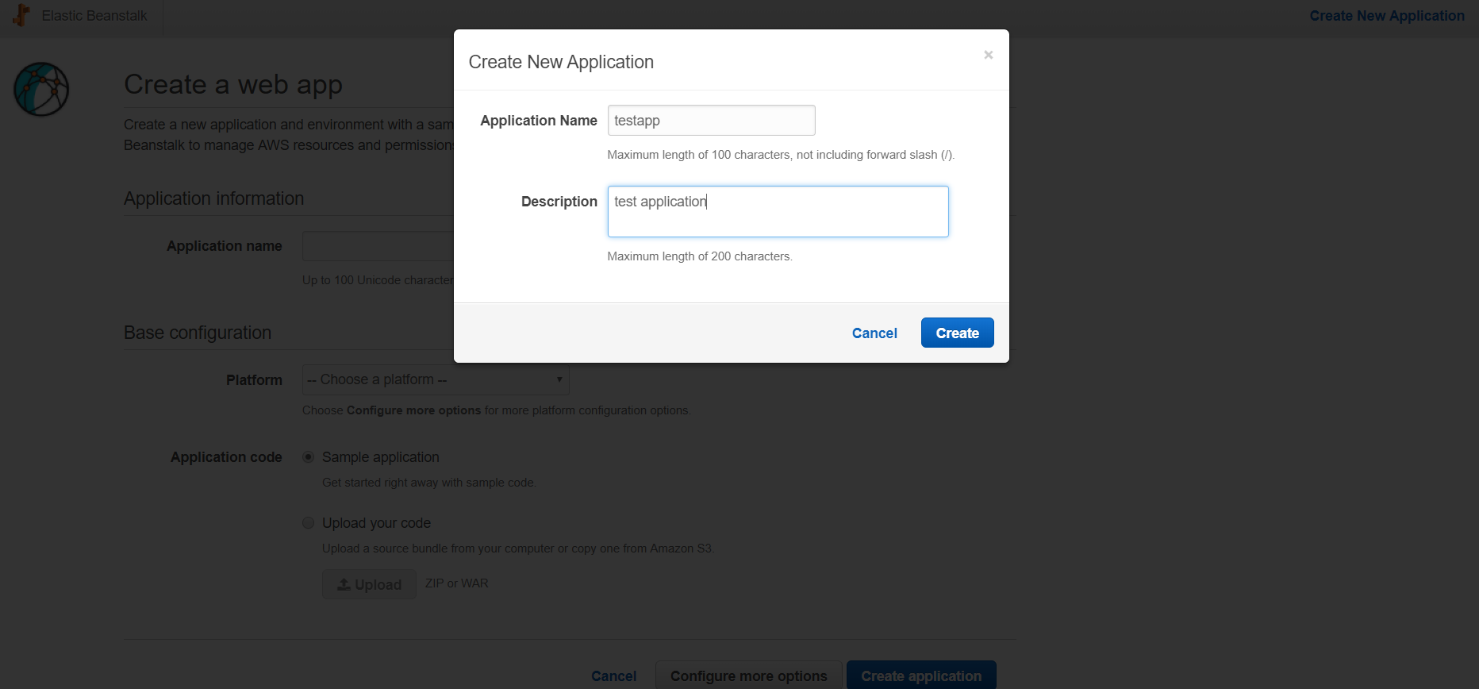
Create Environment.
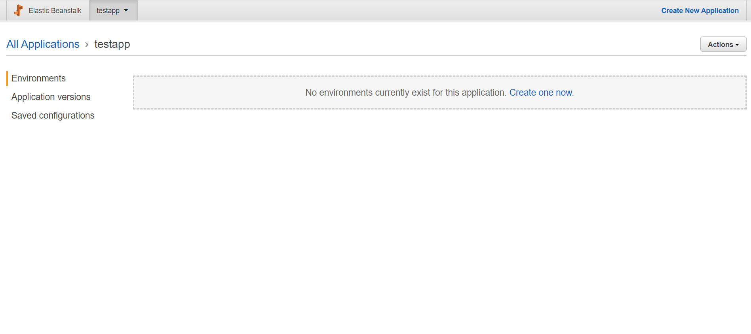
Click “Create one now” and choose web server environment
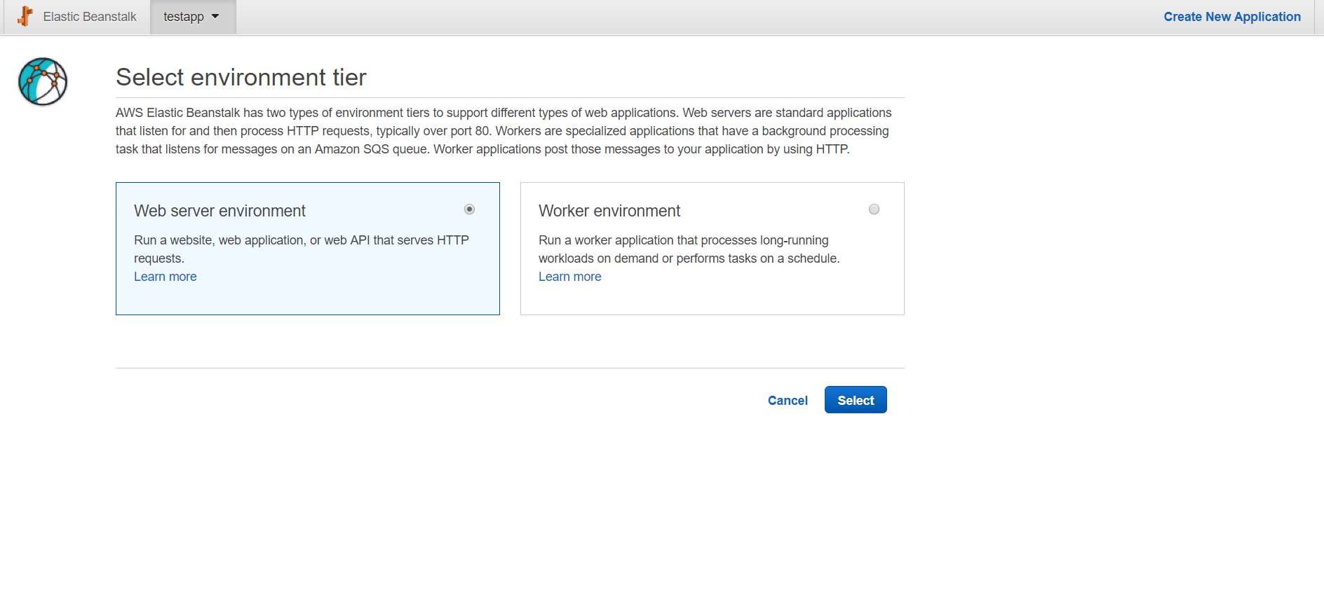
Configure the environment and choose any of the language (Java, python, NodeJS etc.. ) and choose sample application code.
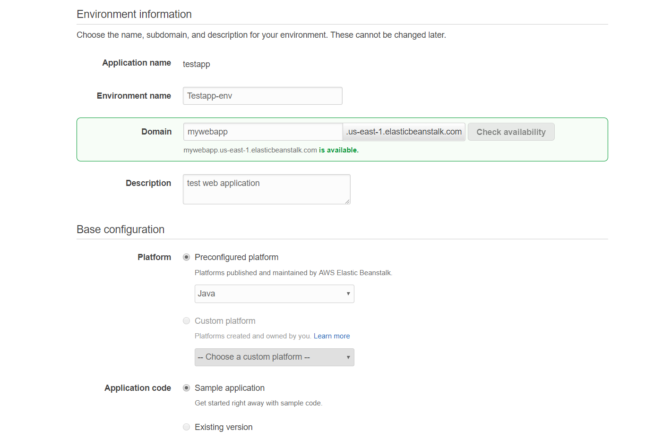
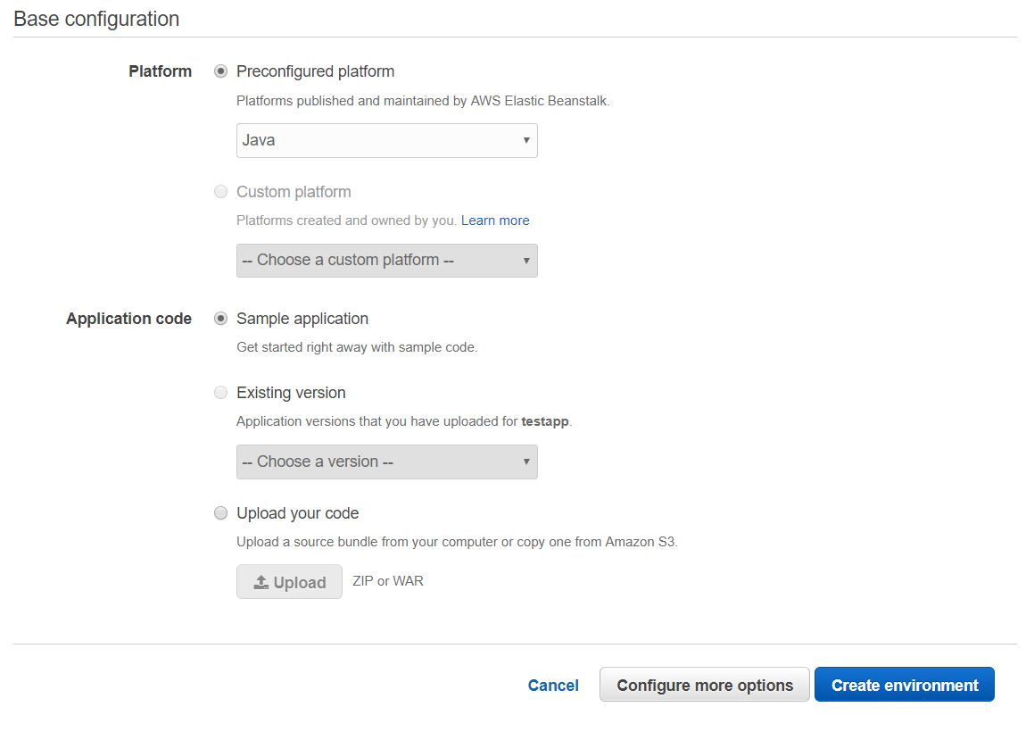

After configuration “Create environment”
You will see the following logs (indicates that the environment creation in progress)
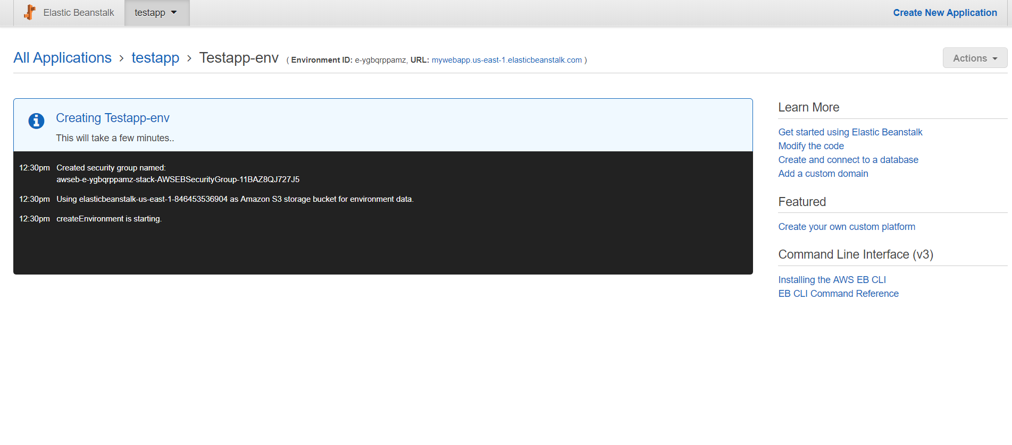
After Environment is created, wait for few minutes until the environment is completely set up. Click the ‘url’ to access your sample application.
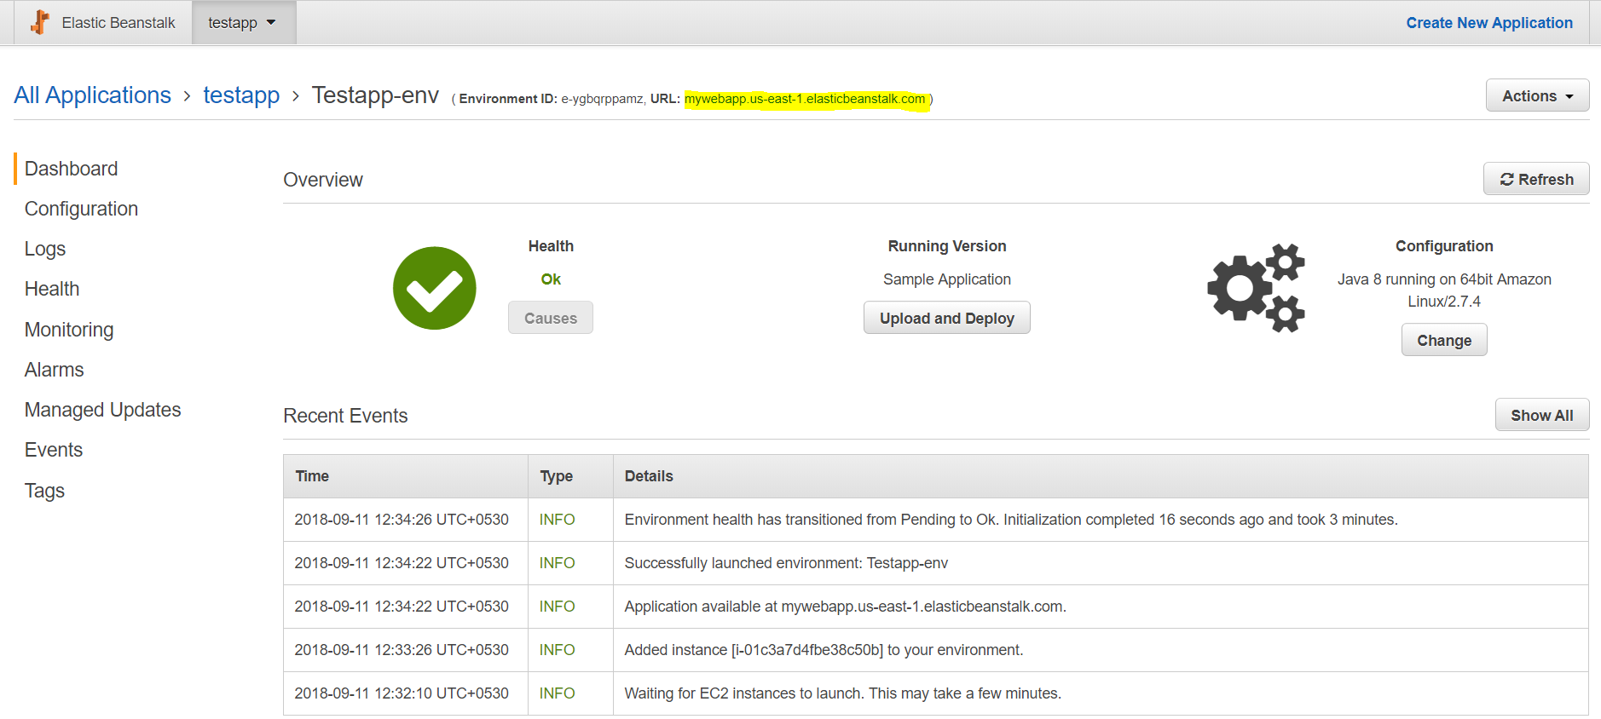

Your application is successfully deployed in Elastic beanstalk.
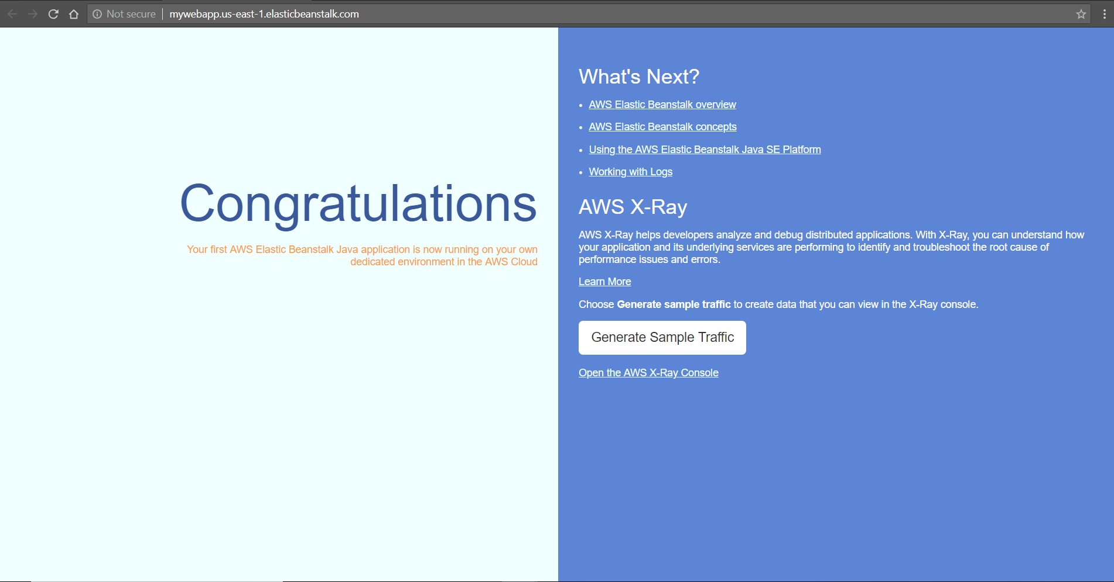

Hope you all uncovering the document accessible and useful.
If you have any demanding question which is mentioned in the document, please feel free to contact us.

Happy Learning
LKM

